Semester 1 2022

ATAR course examination

Question/Answer booklet

**Year 11 ATAR COMPUTER SCIENCE AECSC**

Surname:

Other names:

WA student number (if known)

SIDE Teacher:

SIDE Student Coordinator:

Marking Guide

**Supervisor’s declaration**

I declare that this examination paper has been completed by the student named above. The time and resource restrictions have been observed and the student has NOT accessed notes, texts, reference books, the internet, a computer, a calculator or a mobile phone unless otherwise specified. I understand that breaches of the examination rules could lead to an examination paper being cancelled or having an examination mark significantly lowered.

Supervisor’s name:

Signature: Date:

**Time allowed for this paper**

Reading time before commencing work: ten minutes

Working time: two and a half hours

**Materials required/recommended for this paper**

***To be provided by the supervisor***

This Question/Answer booklet

***To be provided by the candidate***

Standard items: pens (blue/black preferred), pencils (including coloured), sharpener, correction fluid/tape, eraser, ruler, highlighters

Special items: up to three calculators, which do not have the capacity to create or store programmes or text, are permitted in this ATAR course examination, Mathomat and/or Mathaid and/or any system flowchart template

**Important note to candidates**

No other items may be taken into the examination room. It is **your** responsibility to ensure that you do not have unauthorised material. If you have any unauthorised material with you, hand it to the supervisor **before** reading any further.

**Structure of this paper**

|  |  |  |  |  |  |
| --- | --- | --- | --- | --- | --- |
| Section | Number of questions available | Number of questions to be answered | Suggested working time (minutes) | Marks available | Percentage of examination |
| Section One:  Short answer | 24 | 24 | 70 | 112 | 40 |
| Section Two:  Extended answer | 4 | 4 | 110 | 93 | 60 |
|  |  |  |  | **Total** | 100 |

**Instructions to candidates**

1. The rules for the conduct of Western Australian external examinations are detailed in the *Year 12 Information Handbook 2022*. Sitting this examination implies that you agree to abide by these rules.

2. Write your answers in the spaces provided in this Question/Answer Booklet. A blue or black ballpoint or ink pen should be used. Wherever appropriate, fully labelled diagrams, tables and examples should be used to illustrate and support your answers.

3. You must be careful to confine your responses to the specific questions asked and to follow any instructions that are specific to a particular question. Where no specific instructions are given, you should feel free to use a range of formats to express your knowledge and understandings.

4. Spare pages are included at the end of this booklet. They can be used for planning your responses and/or as additional space if required to continue an answer.

* Planning: If you use the spare pages for planning, indicate this clearly at the top of the page.
  + Continuing an answer: If you need to use the space to continue an answer, indicate in the original answer space where the answer is continued, i.e. give the page number. Fill in the number of the question(s) that you are continuing to answer at the top of the page.

**Section 1: Short Answer 40%(112 Marks)**

This section contains **20** questions. You must answer **all** questions. Write your answers in the spaces provided.

Spare pages are included at the end of this booklet. They can be used for planning your responses and/or as additional space if required to continue to answer.

* Planning: If you use the spare pages for planning, indicate this clearly at the top of the page.
* Continuing an answer: If you need to use the space to continue an answer, indicate in the original answer space where the answer is continued, i.e. give the page number. Fill in the number of the question that you are continuing to answer at the top of the page.

Suggested working time: 70 minutes.

**Question 1 (4 marks)**

Discuss the differences between a linear methodology in Project Management and a non-linear or iterative approach.

|  |  |
| --- | --- |
| **Detail** | **Marks** |
| Discusses fully comparing fully 2 to 3 characteristics between the two | 4 |
| Discusses referring to 2/3 characteristics | 3 |
| Discusses referring to 1/2 characteristics | 2 |
| Makes a statement only referring to a characteristic no discussion | 1 |
| **Possible Answer**  A non linear approach is characterised as producing less documentation than a linear approach such as the SDLC. At each phase of the SDLC, documentation such as Context, DFD’s, requirements analysis, feasibility, surveys are produced. In a non-linear approach, the personnel can switch around roles and the client is often knowledgeable and part of the development process. In linear, the client is not considered knowledgeable and each person in the project have a discrete task or expertise generally speaking. |  |

**Question 2 (1 mark)**

In what stage of the System Development Life Cycle does the acquisition of hardware occur?

|  |  |
| --- | --- |
| **Detail** | **Marks** |
| Development | 1 mark |
|  |  |
|  |  |

**Question 3 (13 marks)**

In the table below, draw a line between the document and the stage in the SDLC in which it would occur. Some may occur in more than two stages

|  |  |  |  |  |
| --- | --- | --- | --- | --- |
| Use of CASE tools |  | Preliminary Analysis | | |
| Context Diagram |  |
| Testing plan |  | Analysis | | |
| User requirements |  |
| Training plan |  | Design | | |
| Driver updates schedule |  |
| End User surveys |  | Development | | |
| Entity Relationship Diagram |  |
| User Interview notes |  | Implementation | | |
| Data Flow diagrams |  |
| Economic feasibility report |  | Evaluation | | |
| Document analysis |  |
| Problem statement |  | Maintenance | | |
|  |  |
| **Detail** | | | **Marks** |
| 1 mark per correct stage identified | | | 13 |
|  | | |  |
| **Possible Answer**  See above – DFD/Context can be in analysis and design phases. | | |  |

**Question 4 (2 marks)**

Explain what is meant by logical design?

|  |  |
| --- | --- |
| **Detail** | **Marks** |
| Explains fully what is meant by logical design | 2 |
| Statement about logical design | 1 |
| **Possible answer**  The logical design refers to what the information system should consist of and what must be achieved by the information system. This can include data input and output/hardware as well as general performance standards and security. |  |

**Question 5 (8 marks)**

Complete the following table in relation to secondary storage options.

|  |  |  |
| --- | --- | --- |
| **Storage** | **Solid State Drive** | **Hard Drive** |
| **Advantage 1** | No moving parts so less wear and tear | It is much cheaper to buy |
| **Advantage 2** | Because there are no moving parts, it can start more quickly. | Can be purchased in much larger sizes. |
| **Disadvantage 1** | It is expensive to buy | Because there are moving parts, it can be impacted by wear and tear of these parts. |
| **Disadvantage 2** | It is compact and does not take up a lot of room | Can be large and more bulky than SSD |

|  |  |
| --- | --- |
| **Detail** | **Marks** |
| 1 mark per advantage/disadvantage | 8 |
| **Possible answer**  As above |  |
|  |  |

**Question 6 (8 marks)**

Discuss the following components by identifying their function with a system and their impact on system performance (2 marks each)

CPU Cores:

|  |  |
| --- | --- |
| **Detail** | **Marks** |
| Identifies function and links it to impact on system performance | 2 |
| Brief statement not covering both sides of the question | 1 |
| **Possible answer**  The core is a processing unit within the CPU. The more cores there are, the faster instructions are executed as they can be pipelined. |  |
|  |  |

Clock Speed:

|  |  |
| --- | --- |
| **Detail** | **Marks** |
| Identifies function and links it to impact on system performance | 2 |
| Brief statement not covering both sides of the question | 1 |
| **Possible answer**  An instruction cycle has it’s speed determined by the speed of the clock. So the clock speed regulates how quickly a system can execute an instruction. |  |
|  |  |

Control Bus:

|  |  |
| --- | --- |
| **Detail** | **Marks** |
| Identifies function and links it to impact on system performance | 2 |
| Brief statement not covering both sides of the question | 1 |
| **Possible answer**  Depending how much data the control bus can handle will impact how fast the CPU can communicate with all aspects of the system. So the more data the control bus can handle, the faster the system will go |  |
|  |  |

RAM:

|  |  |
| --- | --- |
| **Detail** | **Marks** |
| Identifies function and links it to impact on system performance | 2 |
| Brief statement not covering both sides of the question | 1 |
| **Possible answer**  RAM does not necessarily impact the performance of the system unless it is full and applications and/or instructions cannot be loaded. If that is the case, the system will be slow. |  |

**Question 7 (2 marks)**

Discuss the difference between custom-built and off-the-shelf software?

|  |  |
| --- | --- |
| **Detail** | **Marks** |
| Discusses the difference between them both by comparing a characteristic | 2 marks |
| Statement that does not discuss or compare fully | 1 mark |
| **Possible answer**  Off-the-shelf software does not make available source code and you usually have to pay money to purchase the software. It is not editable by legal or reliable means. Custom built software has been made specifical to that organisation’s requirements. Frequently it is editable for a cost to change with the organsations changes. |  |

**Question 8 (16 marks)**

Compare and contrast implementation strategies in the following table.

|  |  |  |  |  |
| --- | --- | --- | --- | --- |
|  | **Direct** | **Parallel** | **Pilot** | **Phase-in** |
| **Advantage 1** | It is a cheap alternative to running two systems at the same time. | It is safer, if the new one fails, there will still be one running so less likely a data or financial loss | A small scale introduction means less impact on change over. | Allows sections or departments of the organisation to get used to new system making it easier for troubleshooting |
| **Advantage 2** | It is quicker than other systems as one is swapped out for the other so there are not two systems running at the same time | Allows time for users to get used to new system but can have the comfort of the old system whilst they are trained | Allows trouble shooting before wider scale deployment. The Pilot allows issues to be generated and resolved beforehand | Personnel become used to using it in one area, can help deploy in other areas – ‘system experts’ |
| **Disadvantage 1** | There may be cultural push if a change is progressed too quickly. This could generate bad will and stress. | More expensive as potentially running two systems at the same time on same or different hardware so doubling up | If the system doesn’t work fully then there may be disgruntled employees who sabotage wider scale deployment | Will take longer and there may be integration issues with different departments running different systems |
| **Disadvantage 2** | If there is a direct swap and the new system fails, there could be a considerable loss of data/finance | Users may be resistant to using new system if old one is still available. | Will take longer and be more expensive than direct. There may be multiple iterations and the Pilot is ultimately suitable for a select few and not predictive of problems generated through wider deployment | It will take longer so problems with older system will still prevail and if these are significant, delay may cost further resources and money. |

|  |  |
| --- | --- |
| **Detail** | **Marks** |
| Compares and contrasts advantage/disadvantage relevant to each method | 2 |
| Statement only | 1 |
| **Possible answer**  See above |  |

**Question 8 (2 marks)**

Discuss why training requirements would influence the choice of hardware or software to be purchased?

|  |  |
| --- | --- |
| **Detail** | **Marks** |
| Discussion of training requirements and connection to choice of hardware and software to be purchased | 2 |
| Statement only | 1 |
|  |  |
| **Possible answer**  If the hardware and software of a system are very different to the old system, then there would need to be significant investment into training. So ability to source training and the cost of training would be part of a economic/technical and operational feasibility discussion at the very start. |  |

**Question 9 (2 marks)**

Discuss how would you determine if changing over to a new system has been successful?

|  |  |
| --- | --- |
| **Detail** | **Marks** |
| Discussion of method to determine success of new system | 2 |
| Statement of method only no discussion | 1 |
| **Possible answer**  To determine if the new system has been successful, the users can be surveyed to see if the system meets the user requirements and outcomes identified in the earlier stages of the SDLC. |  |

**Question 10 (8 marks)**

Discuss why the following diagrams are incorrect (2 marks each).

1. Diagram

   Description automatically generatedDiagram, venn diagram

   Description automatically generated

|  |  |
| --- | --- |
| **Detail** | **Marks** |
| Discuss the incorrect logic of this diagram | 2 |
| Statement of rule only | 1 |
| **Possible answer**  This process indicates a miracle. It is producing data without any data going into the process. This does not make sense as processes need data to enter for them to process in the first instance. |  |

b)

|  |  |
| --- | --- |
| **Detail** | **Marks** |
| Discuss the incorrect logic of this diagram | 2 |
| Statement of rule only | 1 |
| **Possible answer**  In this diagram, the data is entering into a system. A store does not belong at the system level diagram or context. A store stores data that has been processed. |  |

c)

|  |  |
| --- | --- |
| **Detail** | **Marks** |
| Discuss the incorrect logic of this diagram | 2 |
| Statement of rule only | 1 |
| **Possible answer**  This is an entity to entity data flow and beyond the scope of the system. The system should have no interest in data exchange between entities. |  |

**Question 11 (6 marks)**

1. Discuss why using public/private key encryption protects data? (2 marks)

|  |  |
| --- | --- |
| **Detail** | **Marks** |
| Discusses why this method protects data | 2 |
| Statement only. | 1 |
| **Possible answer**  Public/private key encryption protects data as it makes it unreadable. So if the data is intercepted, it is unreadable and therefore protected. |  |

1. Discuss how private/private and public/private key encryption works and identify which is more secure. (4 marks)

|  |  |
| --- | --- |
| **Detail** | **Marks** |
| Discussion how each combination works and identifies which is more secure |  |
| Discusses how each side works | 3 |
| Outline of how public/private key encryption works | 2 |
| Statement only | 1 |
| **Possible answer**  The data is encrypted with a public key cipher but can only be decrypted by people with the private key cipher This is known as Asymmetric encryption. They data can also be encoded with a private key and those with the same key can decipher. This is known as symmetric encryption and the private key needs to be kept safe. It is quicker but less safe than asymmetric. |  |

**Question 12 (4 marks)**

1. Discuss why the following Entity Relationship Diagram will produce redundancies in data.

(2 marks)

|  |  |
| --- | --- |
| **Detail** | **Marks** |
| Discusses why the diagram will produce redundancy correctly | 2 |
| Brief statement only | 1 |
| **Possible answer**  Each product could have the same supplier and visa versa so there will be no unique key combination in this situation. |  |

1. How is the above diagram resolved? Illustrate below. (2 marks)

|  |  |
| --- | --- |
| **Detail** | **Marks** |
| Identifies correctly with cardinality correct on both sides and resolving entity | 2 |
| Identifies entity correctly, cardinality wrong |  |
| **Possible answer**   |  |
|  |  |

**Question 13 (3 marks)**

What three methods can be used to implement authentication to protect data in a database?

|  |  |
| --- | --- |
| **Detail** | **Marks** |
| Identifies 3 methods | 3 |
| Identifies 2 methods | 2 |
| Identifies a method | 1 |
| **Possible answer**  Biometric, user names, passwords |  |

**Question 14 (8 marks)**

What is meant by the following database terms?

Atomicity:

Data Integrity:

Data redundancy:

Data field:

Data record:

Primary key:

Foreign key:

|  |  |
| --- | --- |
| **Detail** | **Marks** |
| Correctly identifies what is meant by each term | 1 |
| **Possible answer**  Atomicity: smallest logical size of an attribute ie, postcode separated from address  Data integrity: refers to the accuracy and reliability of the data  Data redundancy: refers to unnecessary repetition of data. Each record must be unique.  Data field: refers to characteristics or attributes of the record  Data record: is a collection of related attributes unique to that instance.  Primary key: is a unique key attribute that identifies a specific and unique record  Foreign key: links a many to one relationship across two different tables by putting the primary key of the one table into the many table. |  |
|  |  |

**Question 15 (3 marks)**

Discuss what is meant by the hierarchical structure of data. Use examples to illustrate your answer.

|  |  |
| --- | --- |
| **Detail** | **Marks** |
| Discusses fully and uses 3 examples to highlight hierarchy | 3 |
| Discusses and uses 2 examples | 2 |
| Limited discussion limited example | 1 |
| **Possible answer**  The hierarchy of data refers to the organisation of data in a manner that represents either increasing size or decreasing singularity. A character in a field in a record in a table. |  |

**Question 16 (8 marks)**

Discuss troubleshooting strategies for the following situations.

**Scenario 1:** An application is running slowly. (2 marks)

1. What would be your first step?

|  |  |
| --- | --- |
| **Detail** | **Marks** |
| Correctly identifies the first step: Close down the application then reopoen. | 1 mark |

1. You have tried (a) and the application is still running slowly.

|  |  |
| --- | --- |
| **Detail** | **Marks** |
| Correctly identifies the next step: Check for updates. | 1 mark |

**Scenario 2:** An application has frozen. (2 marks)

1. What would be your first step?

|  |  |
| --- | --- |
| **Detail** | **Marks** |
| Correctly identifies: Control-alt-delete and shut down the process in the task manager | 1 mark |
|  |  |
|  |  |

1. You have tried (a) and the application is still frozen.

|  |  |
| --- | --- |
| **Detail** | **Marks** |
| Correctly identifies: Restart your computer | 1 mark |
|  |  |
|  |  |

**Scenario 3:** Your computer has frozen (3 marks)

1. What would be your first step?
2. You have tried (a) and it is still frozen.
3. You have tried (a) and (b) and the computer is still frozen.

|  |  |
| --- | --- |
| **Detail** | **Marks** |
| e) control alt delete – locate windows explorer and restart | 1 mark |
| f) press and hold power button for 5-10 seconds | 1 mark |
| g)Unplug power cable – last resort | 1 mark |

**Scenario 4:** Your keyboard and mouse are not communicating with the computer. (1 mark)

1. What is the first thing you should check?

|  |  |
| --- | --- |
| **Detail** | **Marks** |
| Correctly identifies: check connections if wired, if wireless, make sure it is charged and turned on | 1 mark |
|  |  |
|  |  |

Questions 17 – 18 refers to the following scenario

Dr Lois has set up a Medical Practise in Perth and is installing a highly recommended online database to store their patients data. The database software has been developed by SecureOnlineData Pty Ltd. Their company and host server are based in the United Kingdom. They will manage and secure all her data for a monthly fee.

**Question 17**

Discuss the benefits of using an online software solution in this situation. **(3 marks)**

|  |  |
| --- | --- |
| **Detail** | **Marks** |
| Identifies and discusses at least 2 benefits for the online solution | 3 |
| Identifies and discusses 1 benefit | 2 |
| Identifies a benefit | 1 |
| **Possible answer**  Online software is available 24/7 which would allow Dr Lois to access patient data if a hospital contacts her for details or records. In addition, the online software means the data is available from a range of devices in any location. This would also be an advantage in an emergency situation. |  |

**Question 18 (4 marks)**

1. Identify a potential privacy issue in this scenario referring to Australia’s 1988 Privacy Act.

(2 marks)

|  |  |
| --- | --- |
| **Detail** | **Marks** |
| Identifies a potential privacy issue by referring to a principle within the Act | 2 marks |
| Identifies a privacy issue or simply states the principles without relating it to the scenario | 1 |
| **Possible answer**  The Privacy principles within the Act mean that Dr Lois is collecting confidential data and storing it with a third party. If that third part does not have appropriate security around this data, then Dr Lois could be in breach of the Act as it is her responsibility to ensure the data is secured safely. |  |

1. Discuss a potential ethical issue with the storage of data in this scenario. (2 marks)

|  |  |
| --- | --- |
| **Detail** | **Marks** |
| Discusses an ethical issue | 2 |
| Simple statement | 1 |
| **Possible answer**  An ethical issue would be if Dr Lois did not do her due diligence and the third party located in another country was not reputable and used the data for purposes that cannot be a breach because they do not reside in Australia. It could be argued that using a UK company was an ethical breach in the first instance as Australia’s laws may not apply. |  |

**Question 19 (5 marks)**

Discuss the concept of a boot process within a system by identifying the sequence of steps taken from when the power is turned on.

|  |  |
| --- | --- |
| **Detail** | **Marks** |
| Discusses the concept of the boot process and identifies 4 major steps in the correct sequence. | 5 |
| Discusses the concept of the boot process and identifies 4 major steps in the correct sequence | 4 |
| Discusses the concept of the boot process and identifies 3 major steps in the correct sequence | 3 |
| A brief statement about the process and mentions 2 steps | 2 |
| Mentions a step | 1 |
| **Possible answer**  The boot process refers to bootstrapping which is the process by which a system hauls itself up from no power to a fully working system. Picking up by the bootstraps. The sequences starts with power on which the CPU recognises as power is stable. It then locates the initial instruction in ROM BIOs which will be to run the POST.  If the POST runs through OK then the BIOS will look for the boot instructions (which can be anywhere but usually in the hard drive). The next step will be to load the operating system from the Hard drive into RAM and the operating system will then take over the start process. |  |

**Question 20 (2 marks)**

What is the role of a program counter in the Central Processing Unit?

|  |  |
| --- | --- |
| **Detail** | **Marks** |
| Accurately identifies the role of the program counter in the CPU | 2 |
| Makes a statement about program counter with no linkage to CPU | 1 |
| **Possible answer**  The program counter is a register built into the CPU that contains a count of the sequence of instructions. It increments and tells the CPU to fetch the next instruction maintaining a logical order of instructions. |  |

**Section Two: Extended answer 60% (93 Marks)**

This section has **five (5)** questions. Answer **all** questions. Write your answers in the spaces provided.

Spare pages are included at the end of this booklet. They can be used for planning your responses and/or as additional space if required to continue to answer.

* Planning: If you use the spare pages for planning, indicate this clearly at the top of the page.
* Continuing an answer: If you need to use the space to continue an answer, indicate in the original answer space where the answer is continued, i.e. give the page number. Fill in the number of the question that you are continuing to answer at the top of the page.

Suggested working time: 110 minutes.

Refer to your Source Booklet to answer the questions that follow.

**Question 21 (8 marks)**

1. Justify which project management methodology Cheffies should use to introduce a new system into the workplace. (5 marks)

|  |  |
| --- | --- |
| **Detail** | **Marks** |
| Justifies Project management approach by identifying 2-3 strengths of approach and matching them to 2-3 characteristics in the scenario presented. | 5 |
| Justifies Project management approach by identifying 2 strengths of approach and matching them to 2 characteristics in the scenario presented. | 4 |
| Justifies Project management approach by identifying a strength of approach and matching them to a characteristic in the scenario presented. | 3 |
| Makes statement about a strength of the approach and links it to the scenario | 2 |
| Brief statement about approach and characteristic of scenario | 1 |
| **Possible answer**  In this situation, Benjamin is not a knowledgeable user of the technology that will be implemented. In addition, costs will be an important control mechanism here. Whilst this system will only require a small team, given the cost controls required and the documentation needed for Benjamin to use the system, I would recommend a structured approach such as SDLC which will produce this documentation. In addition SDLC can implement more cost controls and it can be completed within a time frame to be negotiated with client. |  |

1. As part of the new system, all of Cheffies employees will be asked to email Benjamin the food items they have taken from the storage facility. One of his new staff members sent an email around to all staff that contained an inappopriate meme they found amusing and wanted to share.

This same staff member also shared their password with their 17 year old child allowed them to access the laptop provided by Cheffies for games.

Benjamin has concerns about the sensitivity of the data contained in the database as well as the offense caused by the inappropriate meme.

Discuss ways in which Benjamin can help minimise incidents like these arising.

(3 marks)

|  |  |
| --- | --- |
| **Detail** | **Marks** |
| Discusses two ways Benjamin can help minimise incidents | 3 |
| Discusses one method of minimising incident(s) | 2 |
| Mentions a method – no discussion | 1 |
| **Possible answer**  To enhance an understanding of Privacy issues within the workplace, Benjamin can develop an ICT code of conduct which makes explicit the responsibilities of employees to maintain data privacy and commercial secrecy.  In the Code of Conduct, Benjamin could also outline email etiquette and have guidelines that demonstrate how company emails should and should not be worded. |  |

**Question 22 (16 marks)**

Referring to the scenario presented on page 2 of the Source booklet, create a Context Diagram for Cheffies system below.

|  |  |
| --- | --- |
| **Detail** | **Marks** |
| Facebook entity  Data flows (all correct, mostly correct, half correct, limited correct) | 1  1-4 |
| Client entity  Data flows (all correct, mostly correct, half correct, limited correct) | 1  1-4 |
| Supplier entity  Data flows (all correct, mostly correct, half correct, limited correct) | 1  1-4 |
| Correct format – system | 1 |
| **Possible Answer – see below** |  |

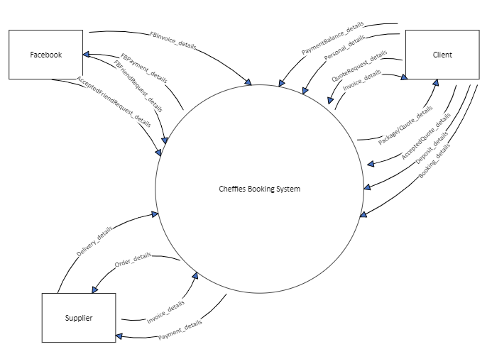

**Question 23 (30 marks)**

Create a DFD Level 0 for the Cheffies system below.

|  |  |
| --- | --- |
| **Detail** | **Marks** |
| Process 1:Correct naming logic  Data flows (all correct, mostly correct, limited correct) | 1  1-3 |
| Process 2 Correct naming logic  Data flows (all correct, mostly correct, limited correct) | 1  1-3 |
| Process 3 Correct naming logic  Data flows (all correct, mostly correct, limited correct) | 1  1-4 |
| Process 4 Correct naming logic  Data flows (all correct, mostly correct, limited correct) | 1  1-4 |
| Process 5 Correct naming logic  Data flows (all correct, mostly correct, limited correct) | 1  1-4 |
| Stores | 1-5 |
| **Possible answer: See below** |  |
|  |  |

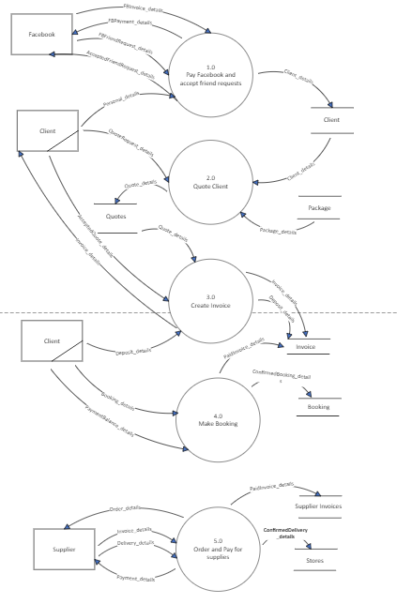

Physical shouldn’t be included

**Question 24 (15 marks)**

Refer to Figure 3 on page 4 of your Source Booklet to answer the following questions.

Any booking over 9 people has a 10% discount applied per person. The ‘Discount’ column reflects this 10% only if the number of people booked is over 9, otherwise it is the set price.

1. Write the formula likely to be contained in the Discount column (G2:G6)? (4 marks)

|  |  |
| --- | --- |
| **Detail** | **Marks** |
| If | 1 |
| Parameter D2>9 | 1 |
| Calculating discounted amount F2 x 0.9 or F2 + (F2 x 0.1) if true | 1 |
| F2 if false | 1 |
|  |  |
| **Possible answer**  =IF(D2>9, F2*0.9, F2) |  |

1. Column ‘Cost Per Person F2:F6 refers to the table data located in A16:C21. Write the formula likely to be contained in the ‘Cost Per person’ column. (5 marks)

|  |  |
| --- | --- |
| **Detail** | **Marks** |
| Vlookup | 1 |
| Correct cell look up E2 | 1 |
| Correct range with correct $ A$16:C$21 | 2 |
| Correct return column | 1 |
|  |  |
| **Possible answer**  =VLOOKUP(E2,A$16:C$21,3,TRUE) |  |

1. Justifies why a relational database may be more suitable for Benjamin than the flat file database he is currently using by discussing advantages and disadvantages of each.

(6 marks)

|  |  |
| --- | --- |
| **Detail** | **Marks** |
| Explains fully and refers to 2 advantages and 2 disadvantages and then arriving at a justified decision | 6 |
| Explains fully and refers to 2 advantages and a disadvantage and then arriving at a justified decision | 5 |
| Explains fully and refers to an advantage and a disadvantage and then arriving at a justified decision | 4 |
| Explains by referring to an advantage and a disadvantage and mentions decision | 3 |
| Refers to an advantage and/or disadvantage and lists choice | 2 |
| Lists choice | 1 |
| **Possible answer**  In the flat file database shown in the Source Booklet, there is limited capacity to establish relationships between customer, booking and invoice. As a consequence there is duplicated data (customer). By going to a relational database, Benjamin can reduce duplication and be able to query the data to print reports that help him plan and cost manage. However the relational database does require an administrator and either Benjamin upskills himself or he employs someone else to do it for him and this would cost money. But not going to a RDBMS means Benjamin misses out on accessing valuable information via reports and queries that could help him make his business more successful. |  |

**Question 25 (24 marks)**

Benjamin is developing a product sheet for each of his dinner/class packages. This allows him to track costs to each of his packages and monitor stock levels in his supplies store.

Create an Entity Relationship Diagram that represents the data in Figures 1,2 and 3. Part of the diagram has been created for you.

You must identify all attributes, cardinality, primary and foreign keys using Chen’s notation.

|  |  |
| --- | --- |
| **Detail** | **Marks** |
| Booking  PK  FK | 1  1  2 |
| Invoice  PK  FK | 1  1  1 |
| Client  PK | 1  1 |
| Dinner package  PK | 1  1 |
| Supplies  PK | 1  1 |
| Dinner package/supplies  PK  FK | 1  1  2 |
| Client/Booking cardinality | 1 |
| Booking/Invoice cardinality | 1 |
| Invoice/Dinner Package cardinality | 1 |
| Dinner package/Dinner package-suppliers cardinality | 1 |
| Dinner package-suppliers/Suppliers cardinality | 1 |
|  |  |
| Chens (all correct, most correct, less than half) | 0-2 |
| **Possible answer**  **See below.**  If students do not include booking – the foreign key client gets transferred onto invoice as do marks and cardinality |  |

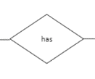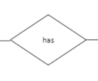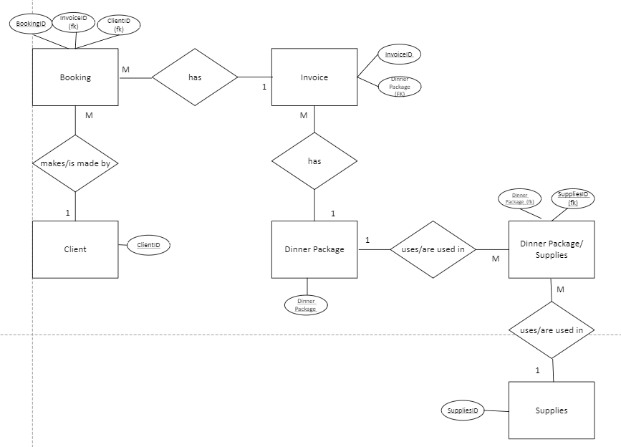

1

1

M

M

Supplier

SupplierID

Order ID

SuppliesID FK

SupplierID FK

Order